STEPS TO UPDATE ASI HELP DATABASE

First, the Advanced Software Help files must be downloaded to your Advantzware DB folder. Once the files named ASIHELP.DB, ASIHELP.B1 and ASIHELP.D1 files our loaded onto the DB folder, then you must run a utility from the existing Progress folder. The best way to access the proper directory is to click the START button, then click ALL PROGRAMS, then click PROGRESS then click PROENV to find the Progress environment. When the DOS prompt appears with the existing Progress folder, type
ProStrct Repair SI_GUI9\DB\ASIHELP.
Please note, the ASI_GUI9 may be named differently on your server, hence replace this command with your properly named folder.

The following options are below.

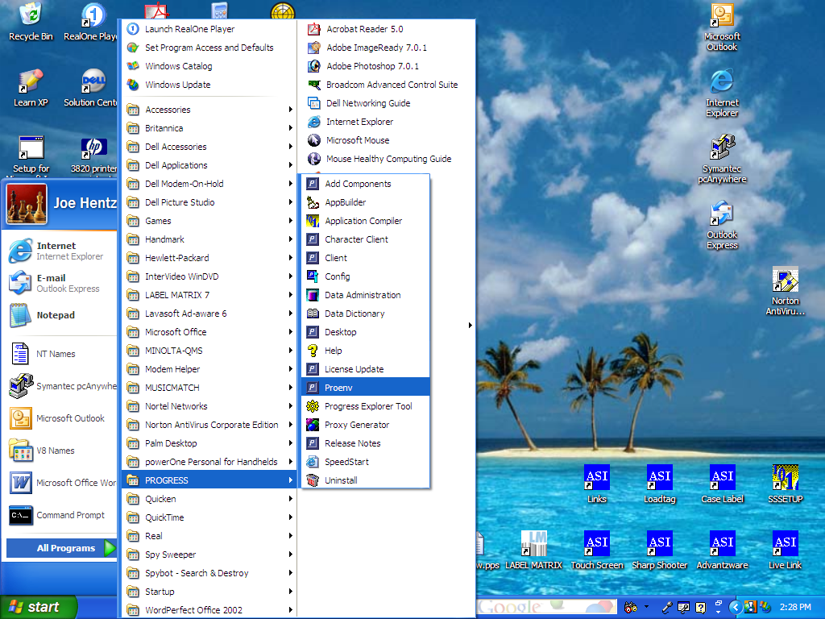

Once the above options are selected, the DOS prompt should default to the Program Files/Progress/Bin folder to the WRK directory or current directory. Once done, run the utility below.
ProStrct Repair SI_GUI9\DB\ASIHELP.
Please note, the ASI_GUI9 may be named differently on your server, hence replace this command with your properly named folder.

